Quilted Zipper Pencil Case

Supplies
- Minimum 4 different fabrics
- Matching thread
- 1 ~ 7" zipper

Instructions:
- Pin pattern pieces to fabric scraps ~ pin points outward
- Call Mrs G before you cut. Cut out pieces
Outer fabric
- Sew together the long edges of 3 small base squares. 2.6 SL 10 line

- Repeat step 3
- Press seam allowances to darker fabric
- Attach upper band to 3 sewn together bands. Sew together using a 2.6 SL following the 15 line.
- Repeat to other side
- Press seam allowances to the darker fabric
Strap
- Fold strap fabric in half lengthwise good sides together.
- Sew together following 10 line. 2.6 SL
- Using a safety pin flip the strap so that the good sides are out.
- Press flat so that the seam is on the side
- Topstitch the long edges of the strap using a 3.5 SL landing 2 mm from the edge.
Zipper
- Make a zipper sandwich. Place 1 piece of outer fabric face up, then the zipper (top facing the outer/pleated fabric) and then the lining right side facing down. Line up the three edges. 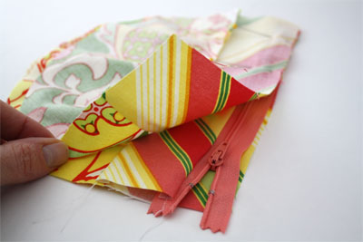
- With a zipper foot sew using a 2.6 SL across the top between the edge of your zipper sandwich and the zipper teeth (closer to the zipper feet). You will need to stop with the needle down and move the zipper past the needle.
- Bring lining and outer fabric to the same side.
- Make another zipper sandwich on the other side of the zipper. Sew the second side using a 2.6 SL close to the zipper teeth.
Assembling
- Fold the strap in half to form a loop.
- Pin the raw edges of the strap to one of the raw edges of the top band centering it in the middle of the height of the band. (the loop should be in the middle of the pouch ~ NOT STICKING out the SIDE)
- Sew in place using a 2.6 SL following the edge of the foot
- Bring both pieces of lining to one side and both pieces of the outer fabric to the other side. Un-zip zipper at least halfway so you can turn it once it is stitched. If you forget to un-zip the zipper you won’t be able to turn your pouch right side out.
- Pinch zipper towards outer fabric, making sure it is laying nicely as you pin.
- Following the 10 line seam stitch all the way around the pouch using a 2.6 SL leaving a 5 cm opening in the bottom of the lining for turning.
- Turn right side out. Machine stitch opening in lining closed using a 3.5 SL 2 mm from the edge (move needle to 7.0 position and follow the edge of the foot).
- Push lining inside the pouch and it is finished!

